Slide 4,12 add latex color

Slide 8 add google scholar link?

Slide 12: text, color latex?: **make it with color**

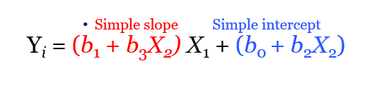

Slide14: picture to latex..

Exercises:**keep them**

Load.csv from canvas?

Some guessing, slide 20 no exercises…